**Ideation Phase**

**Define the Problem Statements**

|  |  |
| --- | --- |
| Date | 15-05-2023 |
| Team ID | NM2023TMID13133 |
| Project Name | AuditAI: A Machine Learning for Detecting Fraud in Audit Data |
| Maximum Marks | 2 Marks |

**Customer Problem Statement Template:**

|  |  |  |  |  |  |
| --- | --- | --- | --- | --- | --- |
| **Problem Statement (PS)** | **Iam (Customer)** | **I’m trying to** | **But** | **Because** | **Which makes me feel** |
| PS-1 | A Business man | To detect the fraud and scams in business | Proper database is not available | Not available of proper audit data, the fraud and scams are not detected | Depressed |
| PS-2 | An Individual | To prevent significant financial losses and protect the integrity of a individual | Difficult to provide proper Audit Data | Fraud, scams and bad agents are damaging in a number of ways | Frustrated |

PS-1:

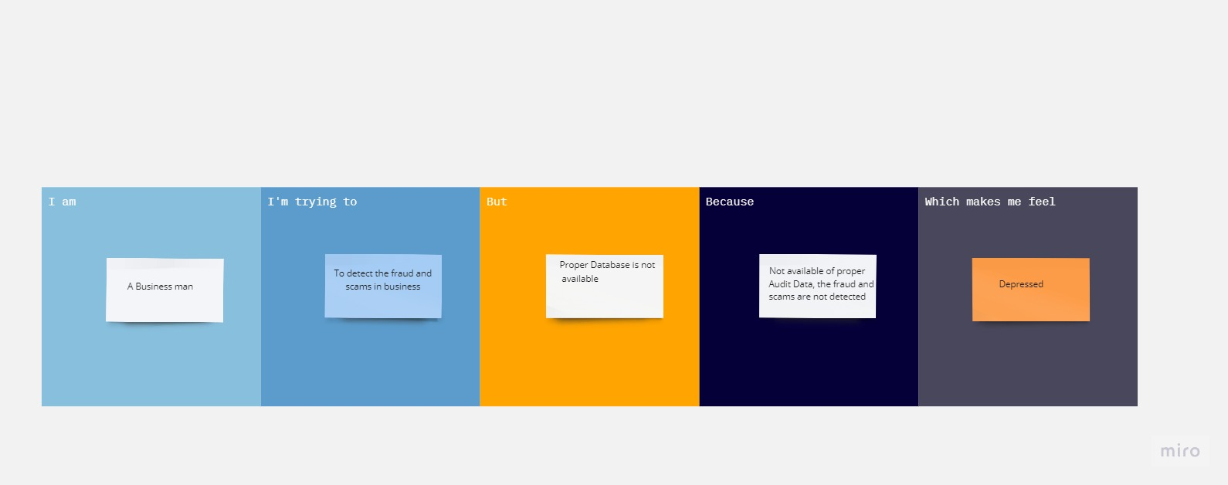

PS-2:

